**Practical-18**

**Aim:-** Create simple MVC web application.

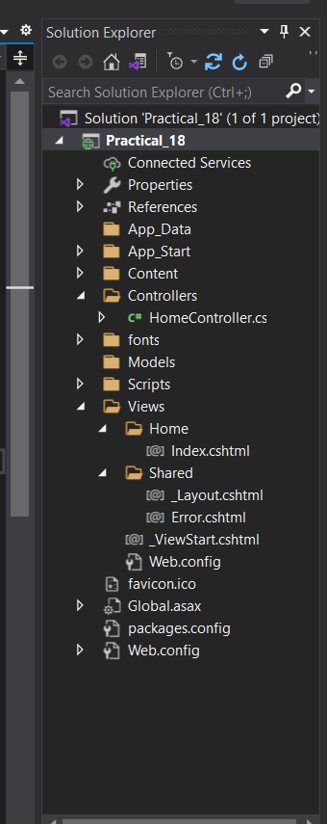

**Controller Folder**

The controller folder contains the controller classes where the operation related code written.

# Model Folder

The Models Folder contains the domain or entity classes. Models can be written anywhere in the solution such as in separate class library or folder etc.

# Views Folder

The Views folder holds the razor pages which are responsible for showing and getting the data from the users.

# Index.cshtml

@{

ViewBag.Title = "Home Page";

}

<h2>@ViewBag.Title.</h2>

<h3>@ViewBag.Message</h3>

# HomeController.cs

using System;

using System.Collections.Generic;

using System.Linq;

using System.Web;

using System.Web.Mvc;

namespace Practical_18.Controllers

{

public class HomeController : Controller

{

public ActionResult Index()

{

//ViewBag.Message = "Your application description page.";

ViewBag.Message = "Vandan Patel Copyright";

return View();

}

}

}

# Layout.cshtml

<!DOCTYPE html>

<html>

<head>

<meta charset="utf-8" />

<meta name="viewport" content="width=device-width, initial-scale=1.0">

<title>@ViewBag.Title - My ASP.NET Application</title>

@Styles.Render("~/Content/css")

@Scripts.Render("~/bundles/modernizr")

</head>

<body>

<div class="navbar navbar-inverse navbar-fixed-top">

<div class="container">

<div class="navbar-header">

<button type="button" class="navbar-toggle" data-toggle="collapse" data-target=".navbar-collapse">

<span class="icon-bar"></span>

<span class="icon-bar"></span>

<span class="icon-bar"></span>

</button>

@Html.ActionLink("Application name", "Index", "Home", new { area = "" }, new { @class = "navbar-brand" })

</div>

<div class="navbar-collapse collapse">

<ul class="nav navbar-nav">

<li>@Html.ActionLink("Home", "Index", "Home")</li>

</ul>

</div>

</div>

</div>

<div class="container body-content">

@RenderBody()

</div>

@Scripts.Render("~/bundles/jquery")

@Scripts.Render("~/bundles/bootstrap")

@RenderSection("scripts", required: false)

</body>

</html>

**Output:**

